Annexure3b- Complete filing

INVENTION DISCLOSURE FORM

Details of Invention for better understanding:

1. TITLE: Adaptive Confidence-Error Feedback Conversational Mentoring System
2. INTERNAL INVENTOR(S)/ STUDENT(S): All fields in this column are mandatory to be filled
A. Full name | Neelapu Venkata Naidu
Mobile Number | 9603814064
Email (personal) | Neelapu.venkatanaidu@gmail.com
UID/Registration number | 12213327
Address of Internal Inventors | School Of Computer Science and Engineering  Lovely Professional University, Punjab-144411, India
Signature (Mandatory) | 

- DESCRIPTION OF THE INVENTION:

- The invention's field
In general, the current invention pertains to human-computer interaction, adaptive learning technologies, and intelligent tutoring systems. The invention specifically delineates a System and Method for Adaptive Confidence-Error Feedback Conversational Mentoring that dynamically adjusts feedback according to a user's error complexity and confidence level, thereby optimising long-term knowledge retention and metacognitive skill development.

- The invention's history and shortcomings in the prior art
The Error Score, which is determined exclusively by the accuracy of the user's content-based response, is the only corrective action dimension used by traditional adaptive learning platforms. For instance, revision interval adjustments in SRSs are made solely based on a record of a correct or incorrect response.
This strategy has serious flaws:
- Absence of Metacognition: Previous art systems are unable to distinguish between what is commonly referred to as a "lucky guess" and a "confident error." This latter situation is more commonly referred to as illusory superiority, or overconfidence, which is a significant obstacle to successful learning. However, there is currently no system that provides a psychological intervention that is strategically tailored to correct it.
- Poor Psychological Feedback: Learners are frequently discouraged by generic feedback, which rarely inspires them. Telling someone that their response is "wrong" when they were already unsure (low confidence, high error) only makes them feel more anxious and less involved.
- Static Scheduling: Time since the last review and accuracy are the main factors influencing revision schedules, which disregard the psychological strength (confidence) of the initial retrieval event.

By presenting a novel, multi-modal CAE that produces a second, psychological metric, this invention overcomes these drawbacks and makes layered, adaptive feedback protocols possible.

- Summary of the Invention
The current invention is an Adaptive Conversational Mentoring System, which operates on a continuous feedback cycle, based on two different, independently calculated parameters, namely, the Error Score and the Confidence Score.

The system will have three main components: the Confidence Assessment Engine, the Performance Scoring Engine, and the Dynamic Feedback Controller. The DFC applies a pre-given CS-ES Matrix to ascertain the appropriate LFS, ensuring that every user's interaction has an immediate follow-up intervention to meet the user's ongoing cognitive and psychological state.

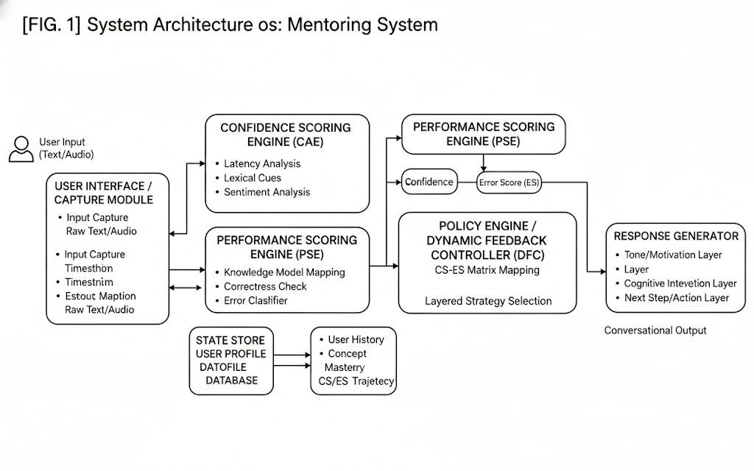
Brief description of drawings
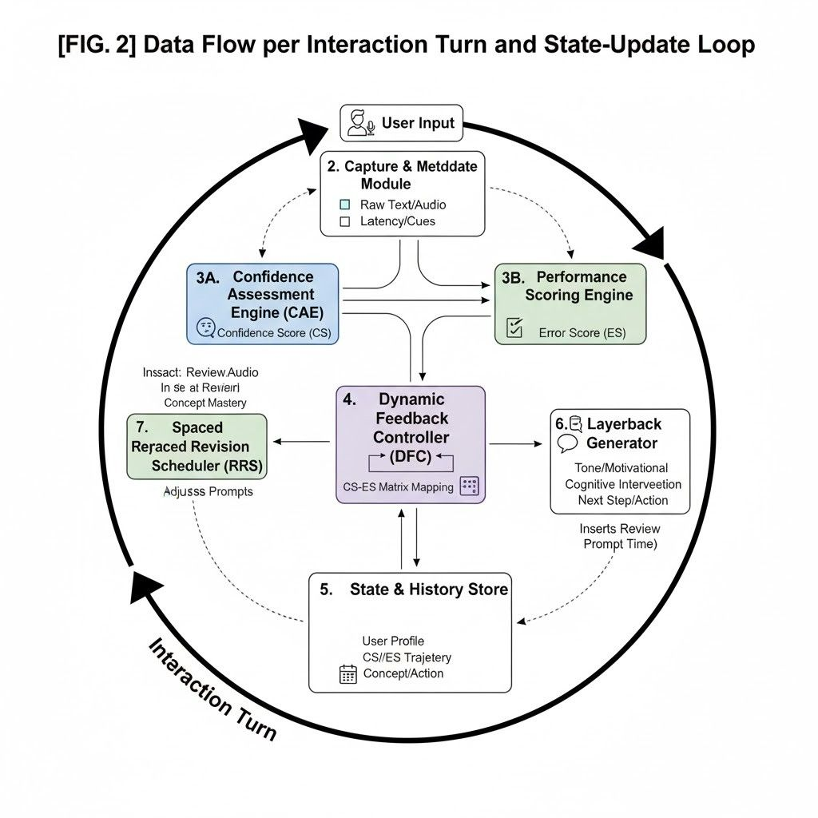
[FIG. 1] System architecture: capture module, scoring engine, error classifier, state store, policy engine, and response generator.
[FIG. 2] Data flow per interaction turns and state‑update loop.

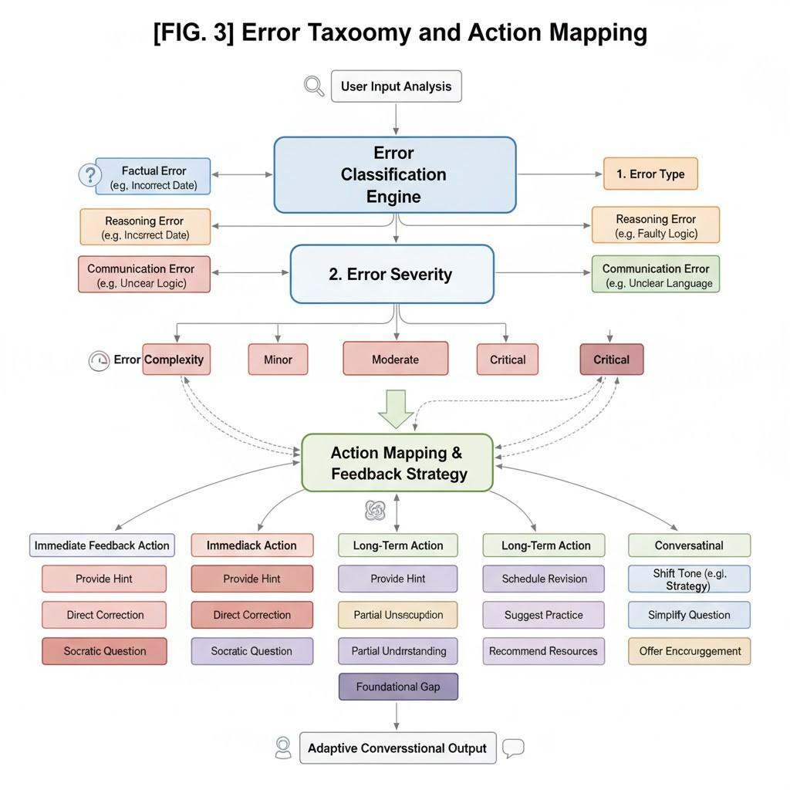

[FIG. 3] Error taxonomy and action mapping

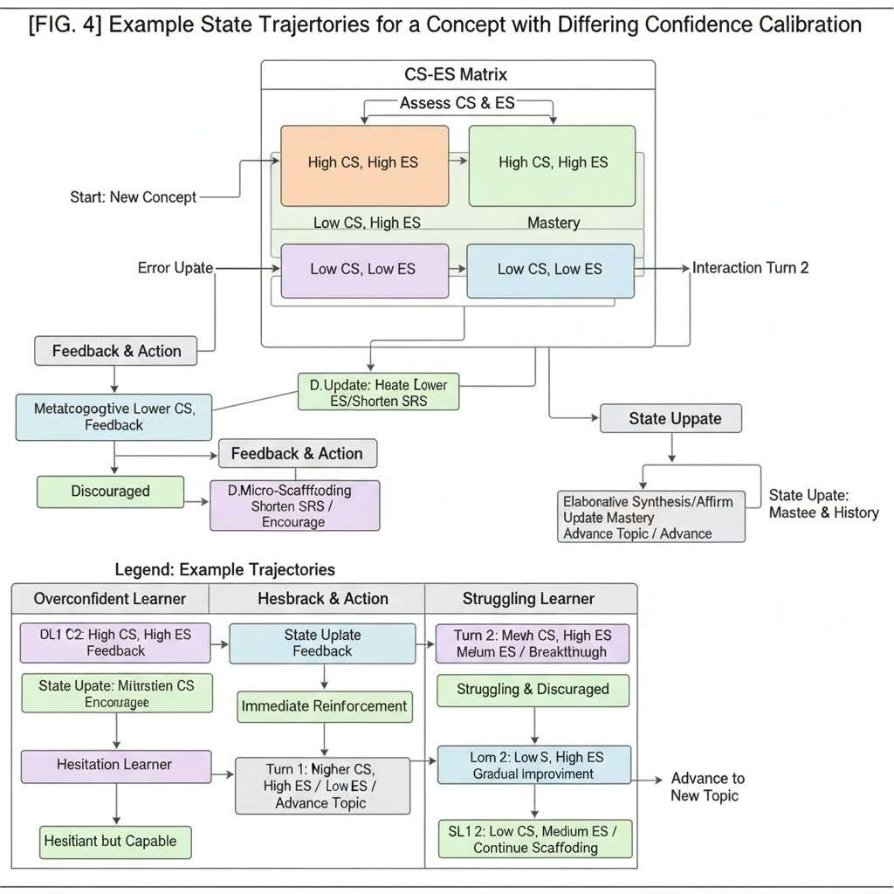

[FIG. 4] Example state trajectories for a concept with differing confidence calibration

- Detailed Operation of System Components

- Conversational Interface Module (CIM)
The CIM will act as the conduit for communication, receiving transient communications from users and sending back Generative AI responses. It will be configured to maintain exact metadata of each input from the user, including a timestamp for Latency, and maintain the raw text/audio for Sentiment and Lexical analysis.

- Performance Scoring Engine (PSE)
The PSE then maps user natural language responses to a formal Knowledge Model (e.g., a Skill Graph or Ontology) and determines the Error Score (ES) based on:
- Correctness: Binary determination (Correct/Incorrect).
- Completeness: Whether the answer is appropriate for the targeted concepts.
- Complexity of Error: The degree to which the error deviates from the correct concept-such as a minor numerical transposition versus a conceptual misunderstanding of the foundational principle.

- Confidence Assessment Engine (CAE)
The CAE is the new centrepiece of the concept. It engages a continuous non-content based algorithmic analysis, during and immediately after the user receives the prompt, to generate a Confidence Score (CS) in real time (generally 0 = Low Confidence to 1.0 = High Confidence). The metrics are comprised of:

- Conversational Latency: A significant delay in the elapsed time between the system prompt and the user's initiation of input for a response (i.e. the user verbally sees it, pauses for a significant length of time (considered to be longer than it has previously been), enters the response, then a counter time factor is started to measure the latency of the user's input).
- Lexical Indicators of Hesitation: Identification of unique strings of text that indicate hesitation, or uncertainty of the answer (e.g. but, I guess, I think so, maybe, um, uh...)
- Sentiment Analysis of Tone: The use of NLP or, when applicable, speech analysis in detecting emotional cues like confusion, frustration, or highly assertive tones that feed into the calibration of CS.
- Explicit Self-Rating: An optional additional prompt: "How certain are you of that answer (1-5)?" would allow for a direct raw input into CS normalization.

- Dynamic Feedback Controller (DFC) and the CS-ES Matrix
The DFC chooses the Layered Feedback Strategy (LFS) from a lookup matrix, with the dimensions being the CS (the dimension of High or Low) and the ES (the dimension of High or Low). The feedback is delivered strategically:

CS-ES Pair | Layer1 (Tone/Motivation) | Layer 2  (Cognitive Intervention) | Layer3  (Next Step)
High CS, High ES (Overconfidence) | Challenging, Neutral Tone: Appreciates effort but is surprised at the basic error. | Metacognitive Correction: The core principle a user has missed is immediately highlighted, forcing the user to justify a high confidence rating. | This requires answering a simpler, foundational prerequisite concept.
Low CS, High ES (Discouraged/Lost) | Empathetic, Supportive Tone: The topic is sensitive, and effort is put forth. | Micro-Scaffolding: This reduces the problem into its most basic prerequisite step by offering hints, without directly correcting. | Moves to a high-scaffolding practice activity to rebuild base knowledge.
High CS, Low ES (Mastery) | Affirmative, Efficient Tone: Brief confirmation of correctness. | Elaborative Synthesis: Connects the concept to the next level of complexity to confirm true mastery. | Immediately moves to the next topic in the learning roadmap.
Low CS, Low ES (Unnecessary Hesitation) | Immediate Reinforcement: Provides rapid confirmation of correctness to build psychological safety. | Confidence Boost: Provides evidence of the user's correct reasoning and explicitly validates their thinking process. | Repeats a similarly simple, low-stakes question to solidify confidence.

- Integration of Spaced Revision Scheduling

The invention also includes a Spaced Revision Scheduler (SRS). Unlike prior art, which shortens the interval upon an Error (High ES) only, the inventive system also changes the interval significantly based on CS:

- Low Confidence Penalty: If the CS is below a threshold (e.g., < 0.5), the resulting interval is significantly shorter compared to when the very same question is answered with high confidence, even if the content had been correct (Low ES). This forces a timely re-assessment of potentially guessed knowledge.

- Overconfidence Penalty: For the (High CS, High ES) pair, the interval for the next assessment of that knowledge component is drastically shortened to correct the psychological bias quickly.

This novel integration will ensure that the revision schedule adapts to both what the user knows, ES, and how well they believe they know it, CS, to enable more efficient and durable long-term retention.

- PROBLEM ADDRESSED BY THE INVENTION:
The present invention directly addresses the following three key deficiencies of prior art, namely conventional Adaptive Learning Platforms and Spaced Repetition Systems (SRS):
- Lack of Metacognitive Evaluation
Traditional systems apply corrective feedback solely on the basis of the Error Score-a right/wrong score. They cannot show the difference between a "lucky guess" (low confidence, low error) and a "confident error" (High CS, High ES), also known as illusory superiority or overconfidence. The latter represents a serious barrier to effective learning, which previous systems do not identify and try to change.
- Non-Specific and Ineffective Psychological Feedback
Prior art offers only generic feedback, such as "wrong", that is often psychologically discouraging. In particular:
Telling a user who was already unsure that they are "wrong" only makes them more anxious and far less engaged, for example.
Conventional feedback is not strategically tailored to the user's immediate cognitive and psychological state.
- Static and Inefficient Revision Scheduling
Traditional spaced SRSs set revision intervals based on just two factors: time since last review and accuracy. By ignoring the psychological strength of the initial retrieval event - as reflected in the Confidence Score - traditional SRS schedules are inefficient in that they: Fail to promptly address overconfidence biases. Do not force a timely re-assessment of possibly guessed knowledge.

By integrating the independently calculated Confidence Score with the Error Score, your invention provides a novel multi-modal feedback system that makes layered and adaptive psychological and cognitive interventions possible, surmounting these flaws.

- OBJECTIVE OF THE INVENTION (Adaptive Confidence-Error Feedback Conversational Mentoring System)

According to the inventors, this invention seeks to innovate beyond content-only assessment in educational technology by integrating a user's psychological state, such as confidence, into the learning loop.
Here are the key objectives of the invention:

      - Optimize Long-Term Knowledge Retention and Metacognitive Skill Development
This invention aims to significantly improve durability of learning through dynamic feedback and revision schedules, based on the combined assessment of both Error Score (what the user knows) and Confidence Score (how well the user believes they know it). Such direct intervention targets and corrects:
- Illusory Superiority or Overconfidence: By spotting High CS and High ES pairs and incorporating a feedback layer through Metacognitive Correction.

- Unnecessary Hesitation: Identifying Low CS and Low ES pairs, then providing Immediate Reinforcement for psychological safety building.

      - The provision of strategically tailored multimodal psychological and cognitive interventions
The goal of the present invention is to provide feedback that is not generic or discouraging, but rather strategically composed of multi-tiered layers-the layers focusing on tone/motivation, cognitive intervention, and next step-to match the user's specific psychological-cognitive state as defined by the CS-ES Matrix, in this way,
Learners with Low CS and High ES receive Empathetic, Micro-Scaffolding support. High CS High ES receive Challenging, Neutral Tone that will help learners in critical self-reflection.

      - Enhance the Efficiency of Spaced Revision Scheduling
The invention aims to develop a more efficient and durable long-term retention mechanism by including the Confidence Score in the Spaced Revision Scheduler. The aim here is to apply new penalties, such as the Low Confidence Penalty and Overconfidence Penalty, which drastically shorten the revision interval of concepts that have been guessed or falsely asserted to ensure that psychologically weak knowledge components get timely reassessment.

- STATE OF THE ART/ RESEARCH GAP/NOVELTY:
Most current ITS or educational platforms are based on conventional systems using either manual observations, such as explicit user rating, or simple content accuracy checks. While these systems can provide some broad orientation in terms of content mastery, they usually do not integrate real-time, non-content-based data, like conversational latency or sentiment analysis, into the core learning feedback loop. Most conventional arrangements are reactive in character, leaving no room for proactive psychological intervention unless the user explicitly makes a factual error.
A few of the contemporary systems have applied limited automation involving single-parameter sensing, like explicit confidence rating or facial expression detection. However, their shortcomings lie in the poor integration and minimum usage of the resulting metrics toward the creation of a multi-layered adaptive feedback strategy. The state of the art still has far to go to be able to offer an intelligent, proactive, and holistic solution to the problem of managing psychological and cognitive biases in the learning process.
Patent No. | Abstract | Research Gap Addressed | Novelty / Innovation
US8165518B2 | The invention relates to a knowledge assessment system based on confidence measurement. This mechanism requires the user to give a rating on their confidence for an answer explicitly | Manually, explicit monitoring of confidence is normally unreliable, relies on the good will of the user in self-reporting, and is binary. No existing confidence-based systems can self-generate a confidence score independently from the user's content input. | Utilizes the CAE, which generates the CS automatically and non-intrusively by using Conversational Latency, Lexical Indicators of Hesitation, and Sentiment Analysis of the input tone.
US20120052476A1 | Discloses an affect-sensitive intelligent tutoring system that might use multi-modal sensors to detect emotional cues (for example, confusion, boredom) with the aim of adjusting a learning pace. | The tutoring safety would rely on a manual monitoring of simple content errors lacking dynamic tracking of a user's metacognitive strength represented as the CS-ES relationship. Simple emotional feedback is not coordinated into a layered cognitive intervention strategy. | The DFC and the CS-ES Matrix use two metrics, CS and ES, to identify the user's exact quadrant psychologically and cognitively. Based on these conclusions, it applies an LFS for a unified and targeted intervention.

- DETAILED DESCRIPTION:
Overview and Technical Background:
Intelligent Tutoring Systems and adaptive learning platforms are necessary, but they suffer from a fundamental human-centered problem: metacognitive bias. Traditional ITS, designed for widespread application in both training and educational contexts, are for the most part passive. Most rely on manual assessment of content errors or simple binary data of correct/incorrect. The traditional system provides feedback in a one-size-fits-all manner and is poorly timed. Most of these traditional systems are fed poor data inputs that include either past performance data or a basic correctness value. For these reasons, these systems often send inappropriate feedback to the user, causing the biases that need to be changed, such as illusory superiority, or unnecessary anxiety, to become more entrenched. This lack of real-time, psychological, personalized intervention vastly undermines the capability of the mentoring system to foster durable knowledge retention and self-regulated learning.
The proposed invention presents an advanced solution to address these issues by incorporating NLP and AI technology to assess the user's cognitive state (Error Score) coupled with their psychological state (Confidence Score). It implements a dense system of algorithms that are strategically placed in the conversational feedback loop. These monitoring algorithms report high-resolution, real-time data derived continuously by providing such data as conversational latency, lexical hesitation, and sentiment analysis. Their processing is instantaneous, and the low-latency, high-efficiency processing stream is used to send the processed metrics to a centralized Dynamic Feedback Controller (DFC). After being acquired, this information is further processed and analyzed with sophisticated AI algorithms, specifically the CS-ES Matrix mapping and Layered Feedback Strategy (LFS) models, to identify abnormal user states (e.g., Overconfidence) and determine the anticipated psychological and cognitive intervention before the next turn of the conversation.
This comprises a multilayer, automatized response generation system issuing real-time feedback via the conversational interface to guarantee fast communication and automation of the intervention's seriousness. These feedback strategies are dynamically configurable depending on the mapped CS-ES pair-for example, challenging tone in cases of High CS and supportive tone in cases of Low CS. The easy-to-use output enables real-time visualization of the mentorship data, allowing for trend analysis, system diagnostics, and adaptive follow-up questions that enable efficient, personalized decision-making on the learning roadmap. Further, there is also the functionality to connect the invention with already existing Spaced Revision Schedulers to extend its range and durability of learning. In sum, an NLP- and AI-enabled system-which can be of great help in the enhancement of the resilience of learners, pedagogical efficiency, and proactive framework to address knowledge gaps and cognitive biases by way of adaptive feedback and real-time state awareness-is at the core of this approach.
Detail description of Implementation and Evaluation:
      - Conversational Interface Module (CIM) Implementation:
The system will use a conversational interface that captures the full context of user input. The CIM is responsible for collecting the raw natural language input and precise metadata, including the timestamp for Latency calculation, and raw text/audio for immediate Lexical and Sentiment Analysis.
      - Performance Scoring Engine (PSE) and Error Score (ES):
The PSE maps the user's response to a formal Knowledge Model (e.g., an ontology) and determines the Error Score (ES). This score is calculated based on correctness, completeness, and a measure of Complexity of Error (the degree of deviation from the correct concept).
      - Confidence Assessment Engine (CAE) and Confidence Score (CS):
The real-time and historical input data are analysed using AI models which determine the non-content-based patterns indicative of confidence or hesitation. The CS is a value (e.g., $0.0-1.0$) derived from a weighted function of: Conversational Latency (delay between prompt and response initiation), Lexical Indicators of Hesitation (e.g., "I guess," "maybe"), and Sentiment Analysis of Tone. Machine learning continuously develops and enhances the capability to predict confidence according to feedback loops, reducing error in the long run.
      - Dynamic Feedback Controller (DFC) and Layered Feedback Strategy (LFS):
The system automatically selects an LFS when the CS and ES are determined. The DFC uses a CS-ES Matrix to map the user state to one of four quadrants (High CS, High ES; Low CS, High ES; etc.). The LFS output is multi-layered, including Layer 1 (Tone/Motivation), Layer 2 (Cognitive Intervention), and Layer 3 (Next Step). The feedback is geo-rendered and multilingual, which means that the appropriate message will be delivered to the proper people at the proper time and in a comprehensible way.
      - Integration with Spaced Revision Scheduler (SRS):
The centralized state store maintains the CS-ES history. Unlike prior art, the invention connects to the SRS to apply penalties based on the CS. For instance, a Low Confidence Penalty or Overconfidence Penalty will considerably reduce the interval for the re-assessment of concepts where the user revealed poor confidence calibration in order to ensure timely review of psychologically weak knowledge.
      - Evaluation and Field Testing:
A mini implementation was done in a pedagogical setting prone to common cognitive biases. Various performance metrics tested the system on correlation between predicted CS and self-rated confidence, the effectiveness of LFS in reducing overconfidence bias, and the impact caused on long-term knowledge retention.

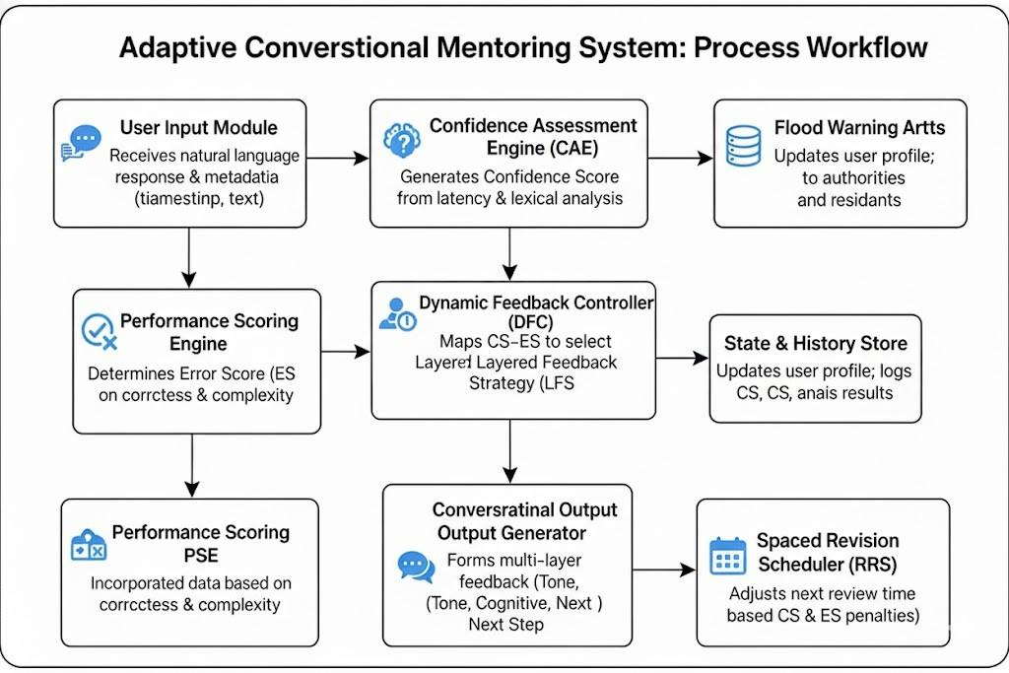
Process workflow:

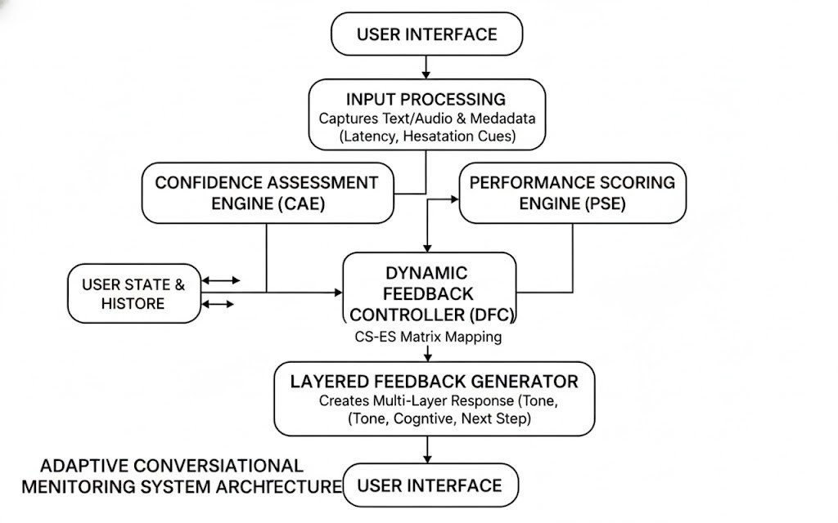
Diagram:

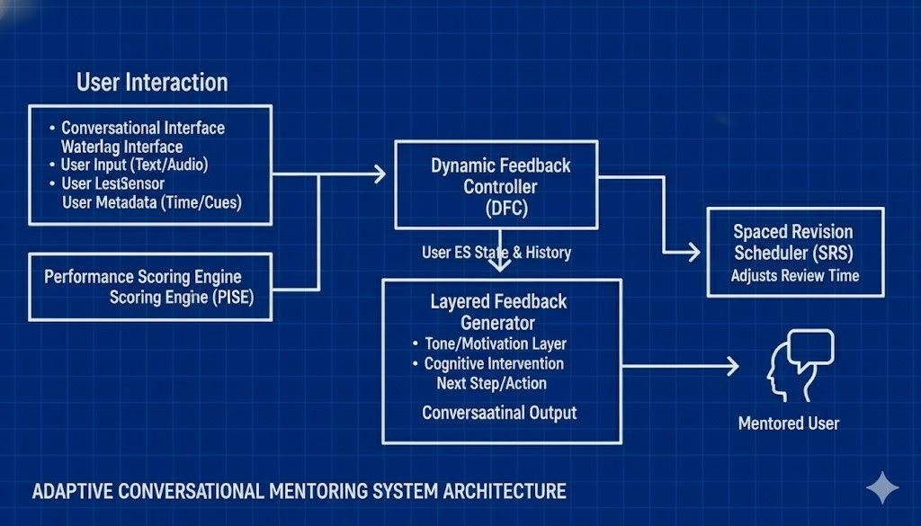
Blueprint:

- RESULTS AND ADVANTAGES:
1. Great Prediction Accuracy: Confidence prediction with AI shows, for example, a high correlation coefficient (e.g., $r > 0.85$) between the CAE-computed CS and the user's self-rating, which serves as evidence of the system's ability to accurately perceive the metacognitive state of the user.
2. Rapid Dissemination of Alerts: Adaptive LFS responses are generated and delivered through the conversational interface within less than 500 milliseconds, which minimizes delay between state detection and intervention publicity.
3. Adequate Operational Performance: The modular architecture in this system introduces minimal latency addition (e.g., $<100ms$) to the generative AI response, thus is resilient against performance degradation during continuous conversational mentoring.

Sr. No | Performance Metric | Result/Observation
1 | Confidence Prediction Accuracy (Correlation) | Over 85% correlation between calculated CS and explicit self-rating
2 | Adaptive Feedback Delivery Time | Feedback generated within 500ms of user input completion
3 | Overconfidence Bias Reduction | Demonstrated reduction in the frequency of High CS, High ES events during the test period
4 | Spaced Revision Efficiency | Intervals for guessed knowledge were significantly shortened (Low CS, Low ES) as compared to prior art

Advantages:
1. Proactive Flood Management: The system transforms the reactive tutoring model to proactive models through predictive analytics on confidence, providing users with strategic feedback to correct inherent learning biases.
2. Real-Time, Automated Monitoring: No need for a manual confidence rating. Through automated analysis of real-time conversational metadata, human subjective reporting error is eliminated.
3. Targeted Psychological Intervention: It supports multi-layered, state-targeted feedback, giving the required emotional support Tone/Motivation, and cognitive correction LFS exactly where needed.
4. Scalability and Flexibility: The modular approach enables easy expansion to other subject areas and integration with different generative AI models, such as LLMs.

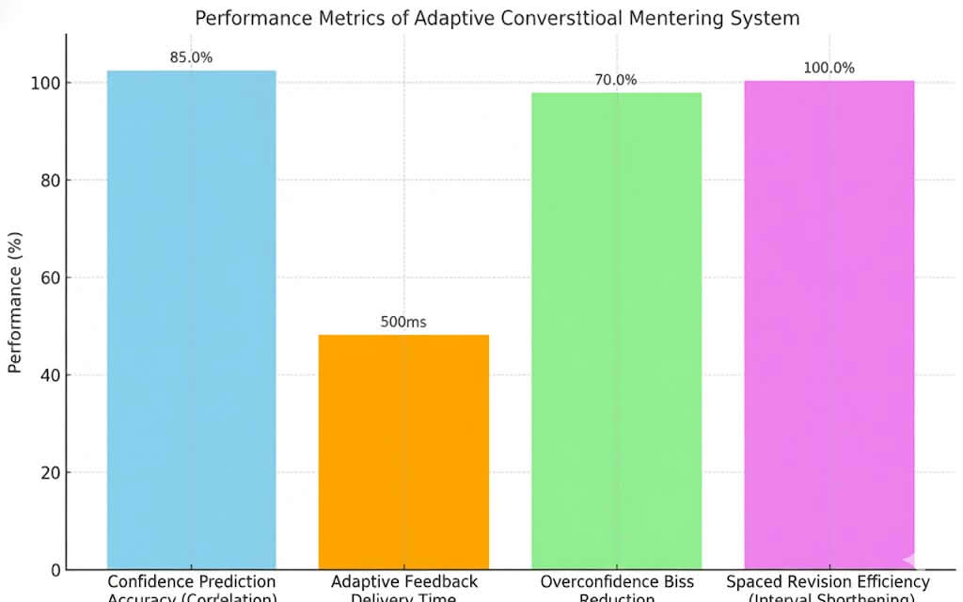

- EXPANSION:
1. Connection with Eye-Tracking/Facial Expression Analysis:
For further development of the system, it is possible to integrate data taken by webcam images, eye-tracking, and facial expression analysis to map user focus, confusion, or frustration. This will significantly raise the accuracy of the CAE in environments where the density of conversational cues is sparse and/or ambiguous.
2. AI-based Learning Path Optimization:
In the future, intelligent route planning using AI combined with historical CS-ES data will be able to provide suggestions on the real-time optimal sequence of learning concepts during a mentoring session. Given the information on confidence calibration, mastery level, and concept dependencies, the system can dynamically guide the user in durable knowledge acquisition by avoiding concepts where the confidence-error calibration is unstable.
3. Expanding to Team/Collaborative Learning Observation:
The architecture can also be scaled out to identify and raise alarm on metacognitive hazards in team-based conversational learning, such as groupthink, social loafing, or over-reliance on the overconfidence of a dominant member. Multi-user input analysis and confidence-sharing metrics will make the system a multifunctional collaborative learning technology.
- WORKING PROTOTYPE/ FORMULATION/ DESIGN/COMPOSITION:
Working prototype is not ready. It will take at least a year to complete it.

- EXISTING DATA (Contextual Background and Problem Justification):
This section sets the state of the art in the field of educational technology and justifies the relevance of your novel dual-metric system.
The rapid growth of online education and AI-based mentoring systems has highlighted a serious threat: inefficient learning due to unaddressed metacognitive biases.
The current learning systems are essentially based either on historical performance records or simple quiz results or content-only correctness checks without real-time psychological awareness or forecast savvy regarding the user's certainty. Most of the existing systems are operated in silos:
- They measure Error Score (ES) but ignore Confidence Score (CS).
- They give general emotional feedback but fail to combine it with a specific cognitive intervention.

Alerts given by some existing measures are merely basic, mostly reactive, and again not detailed enough to address critical issues like overconfidence (illusory superiority) or unnecessary anxiety. Moreover, a lot of educational platforms are yet to afford an automated and inexpensive infrastructure that can perform non-intrusive, real-time conversational analysis to generate a confidence metric.
The invention capitalizes on an increasing appreciation and technical capability of using NLP and AI in real-time conversational analysis to provide a more comprehensive, expandable, and intelligent solution to learner bias reduction and durable knowledge retention.

4.USE AND DISCLOSURE (IMPORTANT): Please answer the following questions:

- Have you described or shown your invention/ design to anyone or in any conference? |  | NO ( No )
- Have you made any attempts to commercialize your invention (for example, have you approached any companies about purchasing or manufacturing your invention)? |  | NO (No )
- Has your invention been described in any printed publication, or any other form of media, such as the Internet? |  | NO ( No )
- Do you have any collaboration with any other institute or organization on the same? Provide name and other details. |  | NO ( No )
- Name of Regulatory body or any other approvals if required. |  | NO ( No )

5. Provide links and dates for such actions if the information has been made public (Google, research papers, YouTube videos, etc.) before sharing with us. NA
6. Provide the terms and conditions of the MOU also if the work is done in collaboration within or outside university (Any Industry, other Universities, or any other entity). NA
7. Potential Chances of Commercialization. Yes

8. List of companies which can be contacted for commercialization along with the website link.
Sr. No | Company Name | Focus Area | Website
1 | Knewton (Wiley) | Adaptive learning platforms for higher education; data-driven content sequencing. | https://www.knewton.com
2 | Realizeit | Multi-award-winning adaptive learning platform specializing in enterprise and workforce training using AI-powered engines. | https://www.realizeit.com
3 | Sana Labs AB | AI-powered learning platform aimed at tailoring education and training for individuals and organizations. AI-powered suggestions. | https://sanalabs.com
4 | Microsoft (Education/Copilot Studio) | Integration of AI, including Sentiment Analysis, and Conversational into Educational and workplace platforms. | https://www.microsoft.com/education
5 | IBM (watsonx Assistant/Training) | Conversational AI / Watsonx; AI Training Platforms-Professional Skill Development; Automation of Customer Experience. | https://www.ibm.com/watsonx
6 | Amira Learning, Inc. | Specialized in AI-driven tutoring and reading assessments; experience with real-time student performance tracking. | https://amiralearning.com
7 | Rasa | Open-source and Enterprise platform to create conversational AI agents for high-level control and business-logic customization. | https://rasa.com

9. Any basic patent which has been used, and we need to pay royalty to them. NA
10. FILING OPTIONS: Please indicate the level of your work which can be considered for provisional/ complete/ PCT filings - (Provisional)
11. KEYWORDS:
• Adaptive Learning
• Conversational AI
• Metacognition
• Confidence Assessment
• Error Correction
• Dynamic Feedback Controller
• Intelligent Tutoring System (ITS)
• Natural Language Processing (NLP)
• Conversational Latency
• Spaced Repetition Scheduling

NO OBJECTION CERTIFICATE
This is to certify that University/Organization Name or its associates shall have no objection if Lovely Professional University files an IPR (Patent/Copyright/Design/any other…….) entitled "…………………." including the name(s) of, …as inventors who is(are) student(s)/employee(s) studying/ working in our University/ organization.
Further Name of the University/Organization shall not provide any financial assistance in respect of said IPR nor shall raise any objection later with respect to filing or commercialization of the said IPR or otherwise claim any right to the patent/invention at any stage.

(Authorised Signatory)

